FQA System

Version <1.3>

Revision History

|  |  |  |  |
| --- | --- | --- | --- |
| **Date** | **Version** | **Description** | **Author** |
| 20/03/2016 | 1.0 | The first version | Xinchi Wang |
| 24/03/2016 | 1.1 | Added Gantt Chart | Xinchi Wang |
| 25/03/2016 | 1.2 | Added Elaboration Phase plans | Xinchi Wang |
| 29/03/2016 | 1.3 | New member joined | Xinchi Wang |

Table of Contents

1. Introduction 4

1.1 Purpose 4

1.2 Scope 4

1.3 Definitions, Acronyms and Abbreviations 4

1.4 References 4

1.5 Overview 4

2. Project Overview 4

2.1 Project Purpose, Scope, and Objectives 4

2.2 Assumptions and Constraints 4

2.3 Project Deliverables 4

3. Project Organization 5

3.1 Organizational Structure 5

3.2 Roles and Responsibilities 5

4. Management Process 6

4.1 Project Plan 6

4.1.1 Phase Plan 6

4.1.2 Iteration Objectives 7

4.1.3 Releases 8

4.2 Iteration Plans 8

4.3 Project Monitoring and Control 8

4.3.1 Schedule Control Plan 8

4.3.2 Quality Control Plan 8

4.3.3 Reporting Plan 9

4.4 Risk Management Plan 9

# 

# Introduction

## Purpose

The purpose of this document is to describe the plan of activities in development of FQA System. It also includes project overview and organization structure.

The intended audience of this document is the prospective software development team.

## Scope

This plan is only associated with FQA System, an online Q/A system using browser/server structure.

## Definitions, Acronyms and Abbreviations

FQA: Find Question and answer

## References

Rational Unified Process, Development Plan template (rup_sdpln.dot)

FQA System Risk Management Plan

## Overview

The rest of this document is divided into three main sections:

* Project Overview is a brief introduction of the project.
* Project Organization describes the organization structure of the team and roles of each team member.
* Management Process describes the plans of development.

# Project Overview

## Project Purpose, Scope, and Objectives

This project is to build an online Q&A system in which users can ask and answer questions. The system should be a website and be deployed on Internet.

## Assumptions and Constraints

* The project must be finished by Week 13.
* We must use C++ or Java for implementation.

## Project Deliverables

The following deliverables will be produced during the project:

* Software Development Plan (this document)
* System Request
* Software Requirement Specification
* Use Case Specifications
* Use Case Realizations
* Domain Model
* Software Architecture Document
* Database Structure Document
* Build

# Project Organization

## Organizational Structure

|  |  |
| --- | --- |
| **Role** | **Names** |
| Project Manager | Xinchi Wang |
| Business Designer | Caixing Su |
| System Analyst | Caixing Su, Xinchi Wang |
| Designer | Rixin Nie, Kaijian Feng |
| Requirement Specifier | Caixing Su, Xinchi Wang, Akshay Lakhanpal |
| Implementer | Rixin Nie, Kaijian Feng |
| Test Designer | Kaijian Feng |
| Tester | Kaijian Feng, Akshay Lakhanpal |
| Tool Specialist | Kaijian Feng |
| Deployment Manager | Kaijian Feng |

## Roles and Responsibilities

Team members have volunteered for the following roles as defined by the Rational Unified Process.

| **Role** | **Description** |
| --- | --- |
| Project Manager | Allocates resources, shapes priorities, coordinates interactions with the customers and users and generally tries to keep the project team focused on the right goal. The project manager establishes a set of practices to ensure the integrity and quality of project artifacts. |
| Business Designer | Details the specification of a part of the organization. The Business Designer specifies the workflow of business use cases in terms of business workers and business entities. It also distributes the behavior of these business workers and business entities-defining their responsibilities, operations, attributes, and relationships. |
| System Analyst | Leads and coordinates requirements elicitation and use-case modeling by outlining the system’s functionality and delimiting the system. |
| Requirements Specifier | Details the specification of a part of the system's functionality by describing the Requirements aspect of one or several use cases and other supporting software requirements. The requirements specifier may also be responsible for a use-case package, and maintains the integrity of that package. |
| Designer | Defines the responsibilities, operations, attributes, and relationships of one or several classes, and determines how they will be adjusted to the implementation environment. In addition, the designer role may have responsibility for one or more design packages, or design subsystems, including any classes owned by the packages or subsystems. |
| Implementer | Responsible for developing and testing components, in accordance with the project's adopted standards, for integration into larger subsystems. When test components, such as drivers or stubs, must be created to support testing, the Implementer is also responsible for developing and testing the test components and corresponding subsystems. |
| Tester | Responsible for the core activities of the test effort, which involves conducting the necessary tests and logging the outcomes of that testing. |
| Tool Specialist | Responsible for the supporting tools on the project. This includes selecting and acquiring tools. The tool specialist also configures and sets up the tools, and verifies that the tools work. |
| Test Designer | Responsible for the planning, design, implementation, and evaluation of testing, including generation of the test plan and test model, implementation of the test procedures, and evaluation of test coverage, test results, and effectiveness. |
| Deployment Manager | Responsible for planning the product's transition to the user community, ensuring those plans are enacted appropriately, managing issues and monitoring progress. |

# Management Process

## Project Plan

### Phase Plan

|  |  |  |  |
| --- | --- | --- | --- |
| **Task Name** | **START DATE** | **END DATE** | **DUARNATION (days)** |
| **Inception Phase** | 10/03/2016 | 29/03/2016 | 19 |
| Design Prototype Pages | 10/03/2016 | 14/03/2016 | 4 |
| Make Function List | 14/03/2016 | 17/03/2016 | 3 |
| Create System Request | 17/03/2016 | 24/03/2016 | 7 |
| Create Development Plan | 17/03/2016 | 24/03/2016 | 7 |
| Configure Version Control | 17/03/2016 | 24/03/2016 | 7 |
| Create SRS | 17/03/2016 | 29/03/2016 | 12 |
| **LCO Milestone** | 29/03/2016 | 29/03/2016 | - |
| **Elaboration Phase** | 24/03/2016 | 21/04/2016 | 27 |
| Design Database | 24/03/2016 | 29/03/2016 | 5 |
| Design Architecture | 24/03/2016 | 3/04/2016 | 9 |
| Configure Enviroment | 29/03/2016 | 3/04/2016 | 4 |
| Identify Use Cases | 29/03/2016 | 12/04/2016 | 13 |
| Build Sample System | 4/04/2016 | 12/04/2016 | 8 |
| Deploy Sample System | 13/04/2016 | 17/04/2016 | 4 |
| Test Sample System | 18/04/2016 | 21/04/2016 | 3 |
| **LCA Milestone** | 21/04/2016 | 21/04/2016 | - |
| **Construction Phase** | 21/04/2016 | 19/05/2016 | 28 |
| **Transition Phase** | 19/05/2016 | 2/06/2016 | 14 |

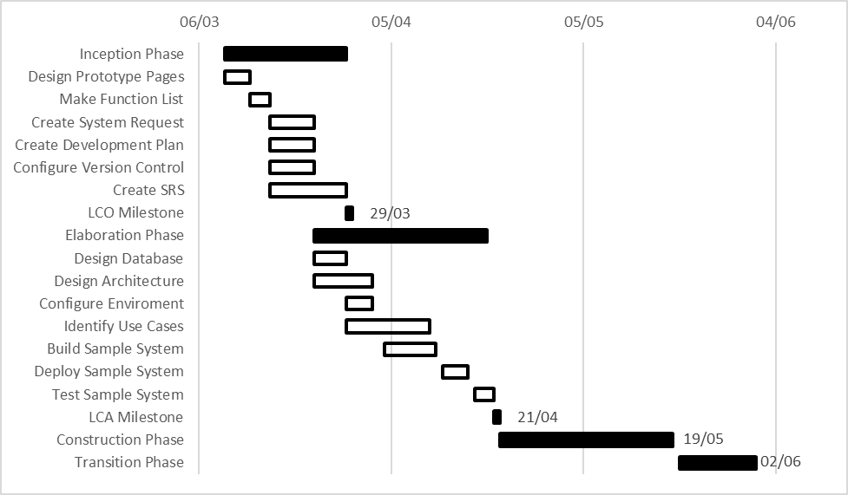

### Iteration Objectives

We choose one week as an iteration, each of which begins with a group meeting.

|  |  |  |  |
| --- | --- | --- | --- |
| **Phase** | **Iteration** | **Description** | **Associated Milestone** |
| Inception | I1 | Designs prototype pages, makes a function list |  |
| I2 | Creates Development Plan, creates System Request, configures version control system, creates Software Requirement Specification |  |
| I3 | Finishes Software Requirement Specification | Lifecycle Objectives Milestone |
| Elaboration | E1 | Designs database and system architecture, Configures implementation environment |  |
| E2 | Identifies use cases, builds sample system |  |
| E3 | Deploys and tests sample system | Lifecycle Architecture Milestone,  Release 0.1 |
| Construction | C1 |  |  |
| C2 |  |  |
| C3 |  |  |
| C4 |  |  |
| Transition | T1 |  |  |
| T2 |  |  |

### Releases

Release 0.1(internal release) is a sample system with basic functions. User should be able to login, ask questions, answer questions, view questions and answers.

## Iteration Plans

|  |  |  |
| --- | --- | --- |
| **Iteration** | **Date** | **Tasks** |
| Inception 1 | 10/03/2016 - 14/03/2016 | Designs prototype pages |
| 15/03/2016 - 17/03/2016 | Makes a function list |
| Inception 2 | 17/03/2016 - 24/03/2016 | Creates Development Plan, creates System Request, configures version control system, creates Software Requirement Specification |
| Inception 3 | 24/03/2016 - 29/03/2016 | Finishes Software Requirement Specification |
| Elaboration 1 | 24/03/2016 - 07/04/2016 | Designs database and system architecture, Configures implementation environment |
| Elaboration 2 | 07/04/2016 - 12/04/2016 | Identifies use cases, builds a sample system |
| Elaboration 3 | 12/04/2016 - 17/04/2016 | Deploys the sample system |
| 17/04/2016 - 21/04/2016 | Tests the sample system |

## Project Monitoring and Control

### Schedule Control Plan

The project manager will maintain a summary schedule showing the expected date of each milestone. Every week, using the weekly team meeting, the project manager will reevaluate the progress of the project, to determine whether the project is on schedule.

If the project is not on schedule, the project manager will consult with team members to determine corrective action, which may result in updating the schedule and/or reducing the number of optional functions that the system will perform.

### Quality Control Plan

All deliverables are required to go through the appropriate review process. The review is required to ensure that each deliverable is of acceptable quality, using guidelines described in the Rational Unified Process [3] review guidelines and checklists.

### Reporting Plan

An assignment report will be generated on 13/04/2016. It will include System Request, Development Plan, Risk Management Plan, Software Requirement Specification, Use Case Specification and Meeting Reports.

## Risk Management Plan

Refer to the FQA System Risk Management Plan